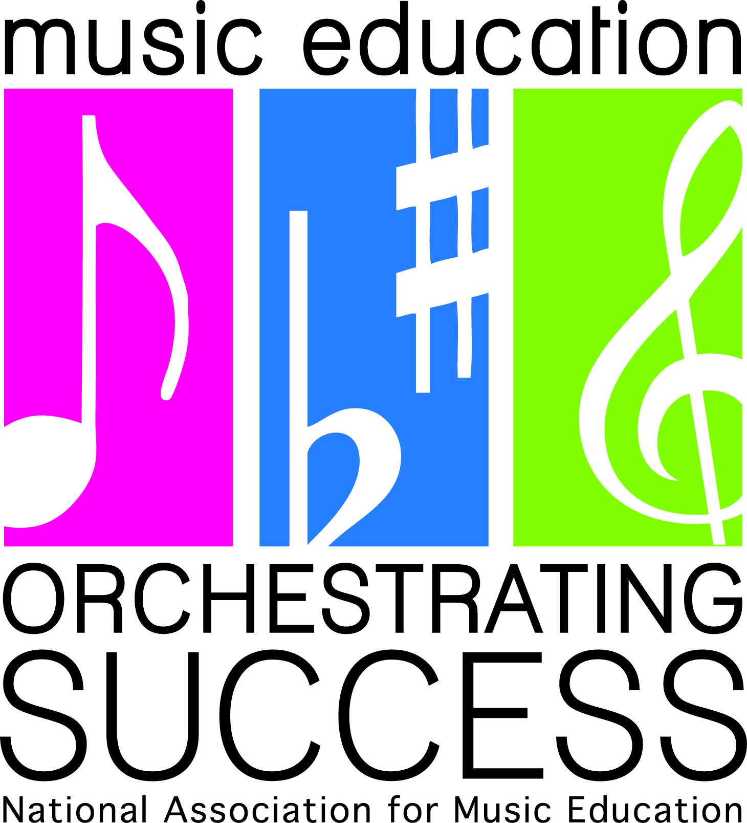
February 25, 2013
MARCH IS MUSIC IN OUR SCHOOLS MONTH (MIOSM)
Dear Superintendent:
As the Virginia Music Educators Association’s (VMEA’s) chair and representative of VMEA’s parent organization, the National Association for Music Education (NAfME), I am writing to thank you for your continued support of music education in our schools. Without your appreciation and understanding of the vital role music plays in all of our lives, especially in those of our students, music in our Virginia schools would not thrive and continue to inspire.
Music touches every human from infancy through adulthood. The power of musical sound is a vehicle for expression, creativity and human emotion. Music is joy. Music is solace. Music has the ability to invigorate and calm us and influence our moods. Music is the poetry of our hearts. Music is our universal language and can bridge our international community; and music is a thread through which we can reach our students. It is only natural then that music, language arts, science, social studies and math are so connected.
Studies continue to show that students who participate in the arts out-perform their non-arts peers on the SAT and other tests. In addition, participation in music education increases children’s creativity, self-discipline, critical thinking, and self-esteem. Research also continues to show that music may be the nutrient that can enhance the development of abstract thinking skills. The study of music and the other arts also provides students with a sense of their cultural heritage. And being that Virginia is very diverse, this can only benefit our students.
Many of your teachers are already planning events to highlight their music education programs during the month of March. We at VMEA and NAfME applaud your music educators.
Although March is the month music educators celebrate music in our schools, we want to make sure music is a part of our students’ lives throughout the school year. We want to point out that your support of these programs is much needed and appreciated as well.
I have attached a PowerPoint for you to view and which you may wish to consider sharing with the music educators in your school districts. It will give an overview of how to celebrate all of your students’ successes in the performing arts and to promote keeping music in our students’ lives.
Again, thank you for your continued support of music education in your schools.
Please contact me anytime I can be of assistance. I look forward to working with you.
Very sincerely yours,
Debra Kay Robinson Lindsay
VMEA Music in Our Schools Month (MIOSM) Chair
National Board Certified Teacher
Fairfax County Public Schools
DebraK.Lindsay@fcps.edu
703.923.5428
http://www.vmea.com/index.php http://nafme.org/

